The Key to the Success of Independent Games

Ben Ying

University of Pittsburgh

INFSCI 2205 (2181)

Argumentative Essay – Final Draft

Have you ever imagined the Matrix becoming reality one day? I hope human beings are still the lord of the virtual world instead of the slaves of computers at that time. In the past, people depicted many strange worlds in pictures, books, movies, and stories. By now, the virtual world often refers to the video games. The pictures or imagery in our dreams can appear in sight today with the development of VR (virtual reality) technology. Many companies launched their VR products in 2016, which symbolized the top of video games industry and ultimate immersion. On the other hand, there are more and more independent studios and developers who work in this field because the market is increasingly mature. In this age of pursuing immersive experiences, as far as I am concerned, in order to improve immersion, telling a good story is a nice choice for most independent developers instead of simply asking for VR’s help.

First of all, the success of a game greatly depends on the immersion. When we look back through history, we can think that the development of games is a process of perfecting immersion. The history started in 1948, Tennis for two produced by William Higginbotham. At that time, the player only saw a movable light spot on the screen. Nowadays, thanks to the VR technology, players can go into the tennis court now without imagining the light spot into tennis anymore. It’s why the immersion is so important for games.

However, immersion is a confusing concept that needs clarification, especially when it’s compared to the gameplay experience. As can be seen in Figure 1, Ermi and Mäyrä (2005) claim that the fundamental components of gameplay include rules, story, and space form diverse dimensions of immersions which constitute the meaning of the game and these elements constitute imaginative immersion, challenge-based immersion, and sensory immersion separately (p. 8). For example, what the VR technology carries out is only an enhancement to the image and the sense of space, it belongs to the sensory immersion, which means developers can also improve immersion through rules and story.

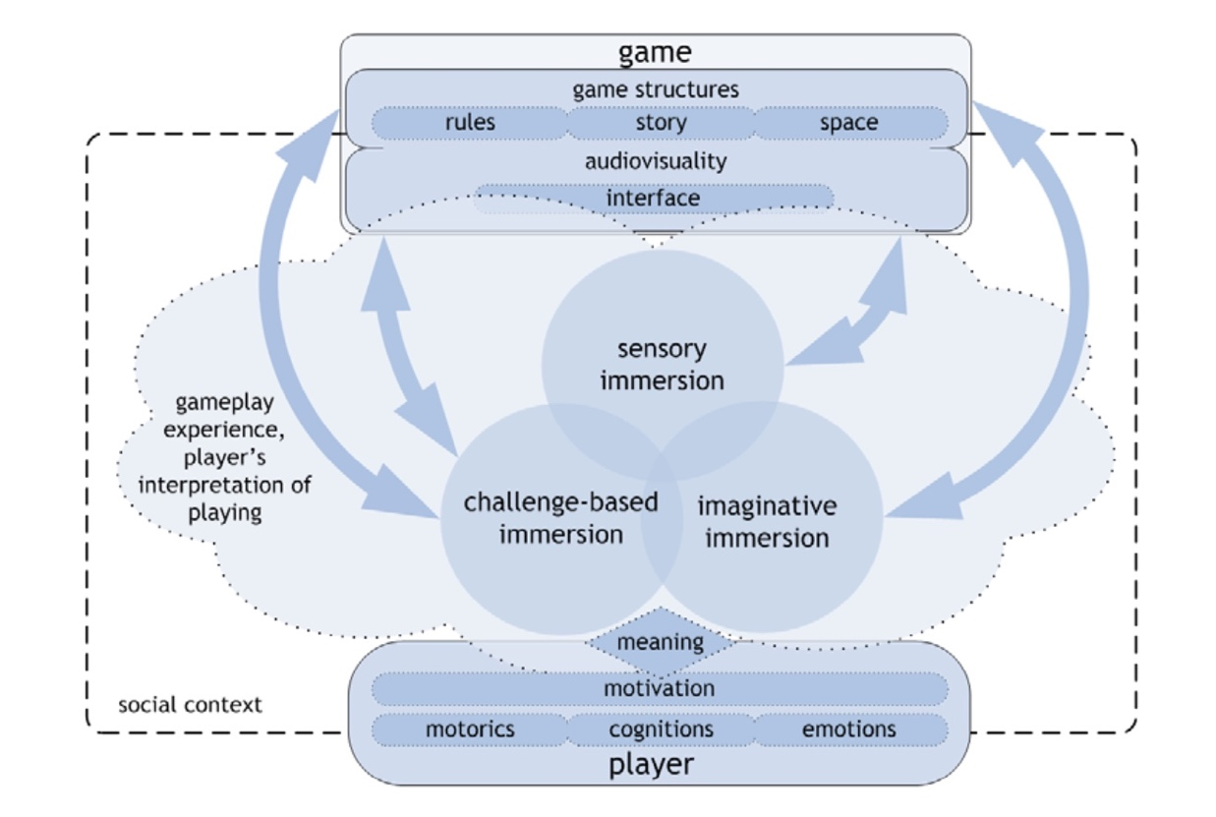

**Figure 1:** gameplay experience model (Ermi and Mäyrä, 2005)

Apparently, the development of games also relates to the technology development and the atmosphere. As such, focusing on story design has a beautiful future. Ermi and Mäyrä (2005) investigated the performance of these three kinds of immersion in many video games (p. 11). Figure 2 shows that several games were launched in the 1990s focused on the challenge-based immersion like Nethack, Rome: Total War, Civilization 3, the score of this immersion are all around 4 and far exceeds the average. At that time, the expressive force of pictures and game capacity were limited by the performance of PCs. With advances in technology, the game developed from 2D to 3D. The sensory immersion began to dominate the immersion. We can also find evidence from the survey, Half-Life 2 is the most popular game in the research and gets the highest score in sensory immersion. Whereas, from an overall perspective, the imaginative immersion is always at a low level, which means the story design has a great space for development.

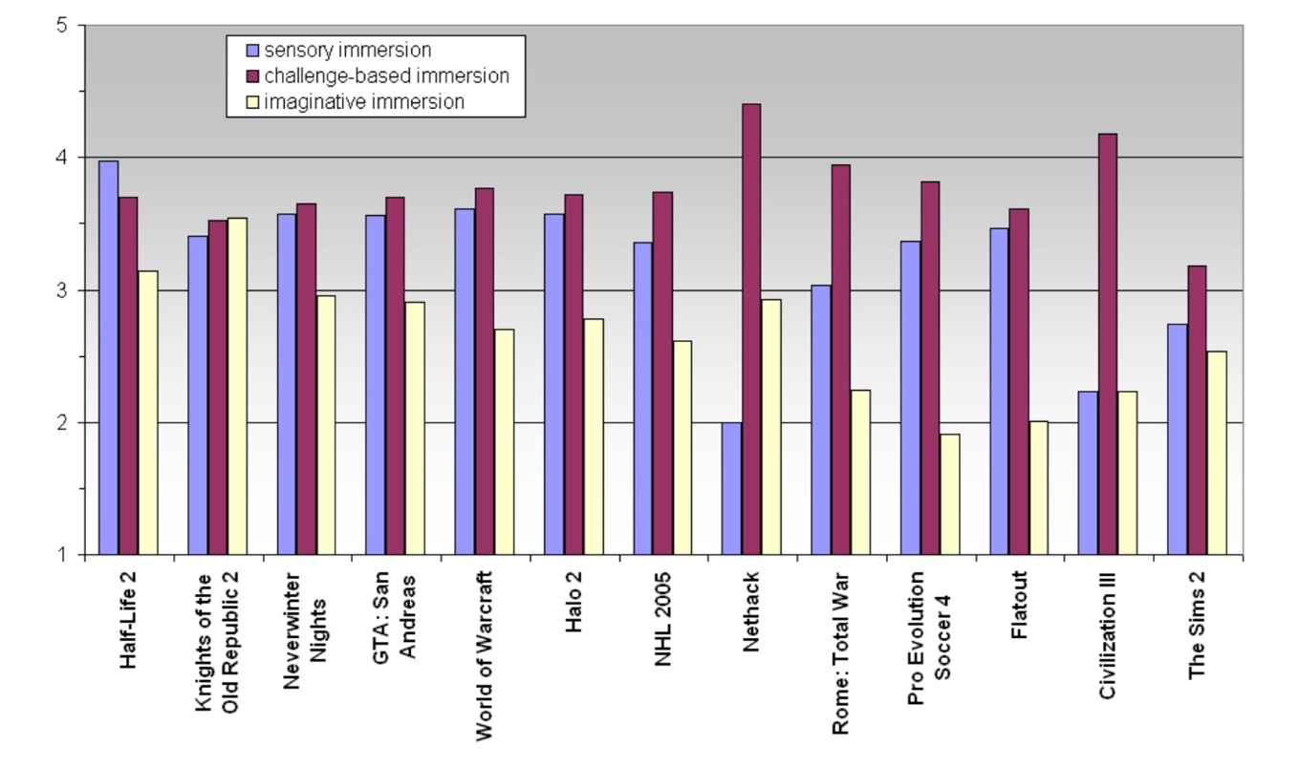

**Figure 2:** The average score of each immersion type (Ermi and Mäyrä, 2005)

Actually, as for storytelling, games can offer more expressiveness than movies or plays. Juul (2001) claims that games have the advantage in storytelling because the traditional media is “performance of a prior story” and on the other hand, players create the story when they play (p. 1) and every choice that players make would affect the ending. Jenkins (2004) supports this opinion too, players can chat with the characters in games, they talk about the problem, think about the solution together and these all enrich the game greatly (p. 128). So, the story could be an interesting factor of games. Developers could have told a better story in games and used it attract players.

And above all, as independent developers, the development capability and the resources are very limited. A good story can help to get rid of the technology weakness. What’s more, the advantages of studios and developers are high working efficiency and high quality as McConnel said (1998, p. 48). Therefore, they can shorten the development cycle so that they pay more attention to the story design than the big companies.

On the contrary, nowadays, the social attributes are becoming a kind of basic element in games. From my perspective, making friends in games could be a part of a story. The real friends convey the real feelings that improve players’ interactions. Take the multiplayer online role-playing game for example, like World of Warcraft(WOW), players organize the guild, trade goods, make friends and the virtual world looks like a small society. Developers can blend social attributes with the story.

Moreover, some companies think no one cares about the story. Easy and interesting are the keys to attracting players. Nonetheless, how to maintain players’ interest and make the game keep hot is also an important question. Even the big companies like Blizzard are contributing to building players’ community. Players create fan works based on the story or character in the game. Their efforts facilitate communication between players while attracting the new players. In terms of WOW, not only does the company publish novels and even make films, but also players create cartoons, videos, and words. Developers and players build the long-living game together.

In conclusion, for the reasons and examples presented above, in consideration of the significance of immersion, the potential of story design, and the developers’ ability, I firmly believe that as independent developers, a game dominated by story can shape the future. Bormann and Greitemeyer (2015) have said that what makes players keep playing is satisfaction, everyone wants to get a sense of pleasure through playing games, it’s the basic element of immersion. (p. 2) But, today the market is inundated with plenty of monotonous mobile games, countless mobile games are produced and forgotten every minute. I hope the new independent games in the future can break the deadlock and be remembered, people can enjoy story in the games just like watch movies or plays.

References

Bormann, D., & Greitemeyer, T. (2015). Immersed in virtual world and minds. *Social Psychological and Personality Science, 6*(6), 646-652. Doi:10.1177/1948550615578177

Ermi, L., & Mäyrä, F. (2005). Fundamental components of the gameplay experience: Analysing immersion. *Worlds in Play: International Perspectives on Digital Games Research*, *37*(2), 37-53. Retrieved from https://books.google.com/books?hl=en&lr=&id=WykINIyYSb0C&oi=fnd&pg=PA37&dq=Fundamental+components+of+the+gameplay+experience&ots=w5KTWKJ71V&sig=2Y6dMLooGA4Y0P_VGrZcgr4jOY0#v=onepage&q=Fundamental%20components%20of%20the%20gameplay%20experience&f=false

Jenkins, H. (2004). Game design as narrative. *Computer*, *44*, 118-130. Retrieved from http://blogs.bgsu.edu/honors1120/files/2013/08/Jenkins_Narrative_Architecture.pdf

Juul, J. (2001). Games telling stories. *Game Studies*, *1*(1), 45. Retrieved from http://www.gamestudies.org/0101/juul-gts/#top

McConnel, S. (1998). *Software project survival guide.* Washington: Microsoft Press